**DAILY ONLINE ACTIVITIES SUMMARY**

|  |  |  |  |  |  |  |  |
| --- | --- | --- | --- | --- | --- | --- | --- |
| **Date:** | **30/06/2020** | | | | **Name:** | **Anusha. K** | |
| **Sem & Sec** | **4th SEM 'A' Section** | | | | **USN:** | **4AL18CS009** | |
| **Online Test Summary** | | | | | | | |
| **Subject** | | **No test** | | | | | |
| **Max. Marks** | |  | | **Score** | |  | |
| **Certification Course Summary** | | | | | | | |
| **Course** | **Statistics for machine learning** | | | | | | |
| **Certificate Provider** | | | **greatlearning academy** | **Duration** | | | **5.6 hours** |
| **Coding Challenges** | | | | | | | |
| **Problem statement 1: Write a C++ Program to Move all zeroes to end of array using Two-Pointers**  **Problem statement 2: Write a C Program to generate first n Ugly Numbers .**  **Problem statement 3: Write a C Program to check whether the number is Ugly or not.** | | | | | | | |
| **Status: completed** | | | | | | | |
| **Uploaded the report in Github** | | | | **yes** | | | |
| **If yes Repository name** | | | | [**https://github.com/anusha20219/Lockdown-coding**](https://github.com/anusha20219/Lockdown-coding) | | | |
| **Uploaded the report in slack** | | | | **yes** | | | |

ONLINE TEST DETAILS: no test

Webinar – Today I attended the webinar on c++ programming organized by department of cse.

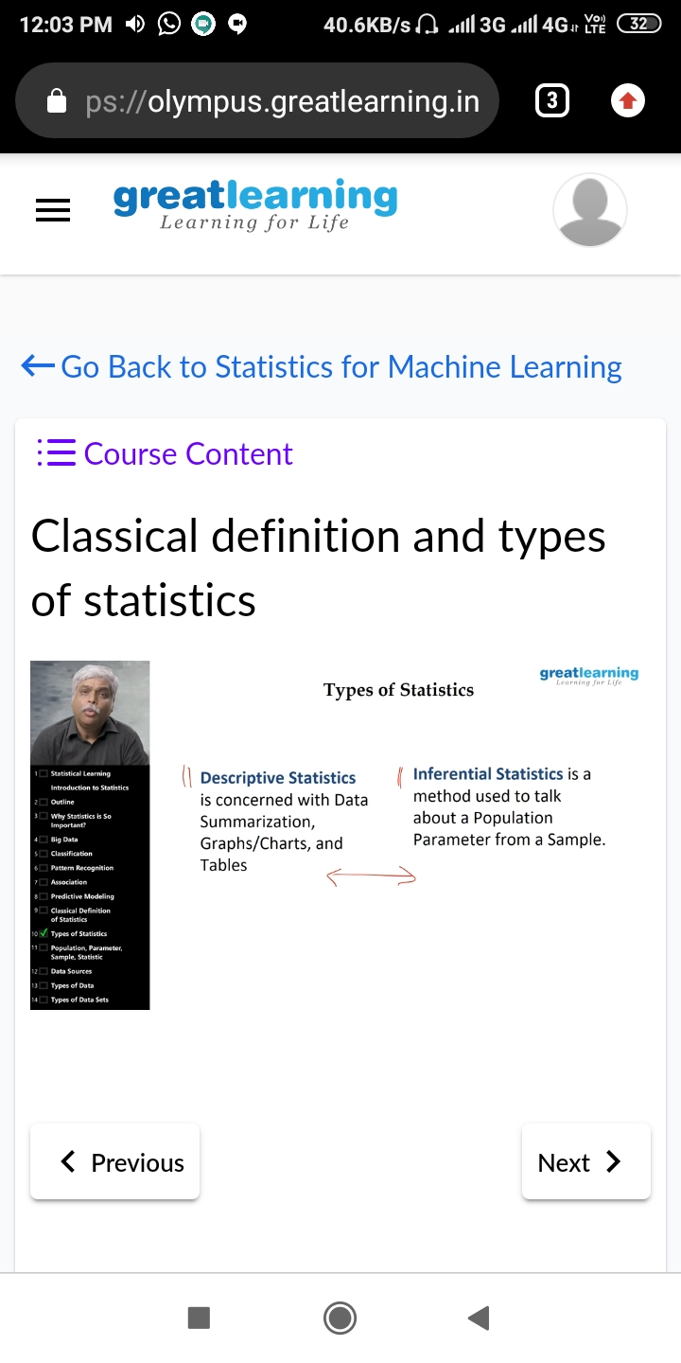**C**ertification course details: Today I attended certification course on the topic statistics for machine learning.

Coding challenge details:

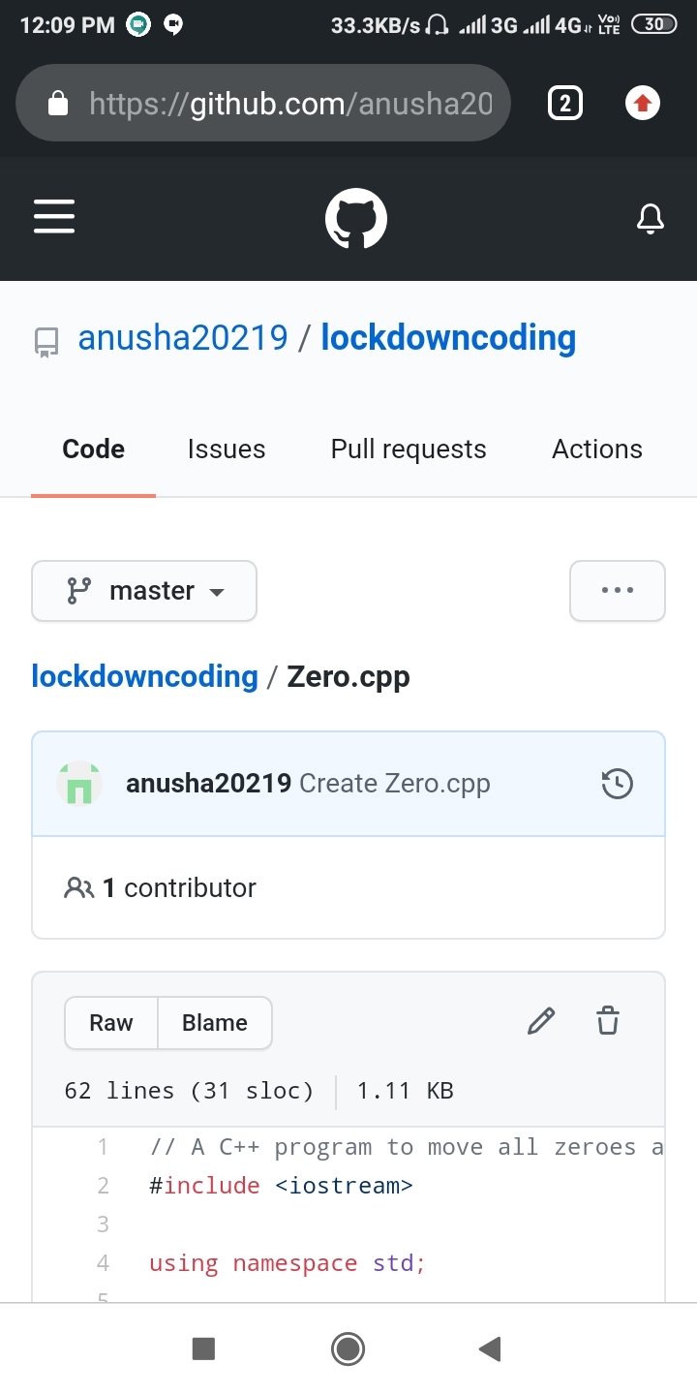Problem statement 1: Write a C++ Program to Move all zeroes to end of array using Two-Pointers.

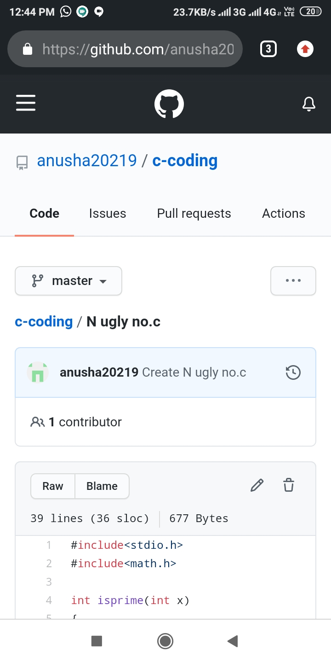Problem statement 2:Write a C Program to generate first n Ugly Numbers .

Problem statement 3: Write a C Program to check whether the number is Ugly or not.

